Final Assessment-Alternative Assessment
Semester | 202520 | Division | CIS
Assessment title in Syllabus | Final_Project_Portfolio | Program | Bachelor of Information Technology/ Bachelor of Information Systems
Course Code | CDS 2413
Course Title | INTRODUCTION TO DATA SCIENCE
Course Instructor | Mohd Salihan Ab Rahman | CRN | 23715
Assessment | Project Deliverable 2 – Machine Learning Model Report | Submission Date | Week 13
Student Declaration:
Academic Integrity Statement
In accordance with the HCT Academic Integrity Policy
• Students are required to refrain from all forms of academic integrity breaches as defined and explained by HCT.
• A student found guilty of having committed acts of academic integrity breach(es) will be subject to the relevant sanctions as outlined by HCT.
إفادة النزاهة الأكاديمية
وفقًا لسياسة كليات التقنية العليا للنزاهة الأكاديمية
• على الطلبة الإلتزام بلوائح وقواعد النزاهة الأكاديمية، كما هو مبيّن وموضح في السياسات والإجراءات الخاصة بكليات التقنية العليا.
• في حالة ارتكاب الطالب أي شكل من أشكال الإخلال بالنزاهة الأكاديمية، سيتعرض الى العقوبات الموضحة في السياسات ذات الصلة.
This assignment is entirely my/our own work except where I have duly acknowledged other sources in the text and listed those sources at the end of the assignment. I have not previously submitted this work to the HCT, or any other entity. I understand that I may be orally examined on my submission.

Student HCT ID(s): | H00573368 | H00531153 | H00530999 | H00543675
Student Name(s): | Zayed Mohamed Almarzouqi | Zayed Ebrahim Alhammadi | Saeed Aljabri | Bader almazroui
Student Signature
Chatbot (e.g. ChatGPT) statement
This submission allows you to use AI generated tools, but the prompt used must be stated and the response must be in red font. Include References to ChatGPT.

Instructions

Remove instructions and hints from the template before submitting the final report to BBLearn.
CLO3: Machine Learning Model (25 Points)
Part 1: Preprocessing (5 Points)
1.1 Data Collection (1 Point)
To load the Marks.csv dataset, the pandas library was used via pd.read_csv(). This is the standard Python library for reading, manipulating, and analysing structured/tabular data. Supporting libraries include numpy for numerical operations and openpyxl for Excel files.
Independent Variables (X): Quiz, Practical, Project, Final — the input features used to predict the outcome.
Dependent Variable (y): Total — a weighted sum computed as:
Total = 0.1 × Quiz + 0.3 × Practical + 0.3 × Project + 0.3 × Final
The weights reflect each component's contribution to the final grade as defined in the course assessment structure.

1.2 Data Cleaning (1 Point)
Strategy 1 — Handling Missing Values (Mean Imputation):
Missing values in each numerical column were identified and replaced using the column mean via sklearn's SimpleImputer (strategy='mean'). This preserves the dataset size and does not distort the overall distribution. For example, if two entries in the Quiz column were missing and the column mean was 71.49, those entries were replaced with 71.49.
Strategy 2 — Outlier Detection and Removal (IQR Method):
Outliers were detected for each variable using the Interquartile Range (IQR) method. Values falling outside [Q1 − 1.5×IQR, Q3 + 1.5×IQR] were flagged and removed. A total of 4 rows were removed. Removing outliers ensures the models are not biased by extreme, unrepresentative data points.
Example: Quiz — Q1=63.45, Q3=78.15, IQR=14.70 → Lower=41.40, Upper=100.20. Values below 41.40 were flagged.

1.3 Treating Categorical Variables (1 Point)
After examining all columns in the Marks.csv dataset, it was confirmed that all independent variables (Quiz, Practical, Project, Final) and the derived dependent variable (Total) are continuous numerical variables. No categorical variables (nominal, ordinal, or binary) are present in the regression dataset, so no encoding was required.
However, for the Classification task, the continuous Total variable was converted into an ordinal categorical variable (Grade) using the following criterion aligned with HCT's grading policy:
- Grade A: Total ≥ 90 (Excellent)
- Grade B: 75 ≤ Total < 90 (Good)
- Grade C: 60 ≤ Total < 75 (Satisfactory)
- Grade D: 50 ≤ Total < 60 (Needs Improvement)
- Grade F: Total < 50 (Fail)
Since the classifiers used accept string labels natively, Label Encoding was not required. If encoding were needed, Ordinal Encoding would be the most appropriate as it preserves the natural ordering F < D < C < B < A.

1.4 Splitting the Dataset (1 Point)
Why splitting is important:
Splitting the dataset into training and testing subsets is essential to evaluate a model's ability to generalise to unseen data. If a model is evaluated on the same data it was trained on, it produces overly optimistic results (overfitting). The held-out test set provides an unbiased performance estimate.
Proportions used:
- Training Set: 80% — provides sufficient data for the model to learn patterns (158 records)
- Testing Set: 20% — provides a reliable evaluation of the model (40 records)
The 80/20 split is the widely accepted industry standard for medium-sized datasets. The random_state=42 parameter ensures reproducibility, meaning every run produces the same split.

1.5 Feature Scaling (1 Point)
Feature scaling was applied using StandardScaler (Z-score Normalisation). This transforms each feature to have mean=0 and standard deviation=1 using the formula: z = (x − mean) / std.
Justification:
- Ridge, Lasso, and Elastic Net models use regularisation penalties that are sensitive to feature magnitude. Without scaling, features with larger numeric ranges dominate the penalty term.
- KNN and SVM classifiers rely on Euclidean distance. Unscaled features with large ranges distort distance calculations and degrade model performance.
- Applying a consistent scaler ensures fair model comparison and reproducible predictions.

Part 2: Regression Model (7 Points)
2.1 Five Regression Models — Implementation
Five regression models were implemented using scikit-learn to predict the Total score. All models were trained on 80% of the scaled data and evaluated on the remaining 20%.

Model | Description | Regularisation
Linear Regression | Fits an optimal hyperplane by minimising Mean Squared Error (MSE). Baseline model. | None
Polynomial Regression (d=2) | Extends linear regression by adding squared and interaction terms to capture non-linear relationships. | None
Ridge Regression | Linear regression with L2 regularisation. Shrinks all coefficients to reduce overfitting. | L2 (α=1.0)
Lasso Regression | Linear regression with L1 regularisation. Can set some coefficients to exactly zero (feature selection). | L1 (α=0.01)
Elastic Net | Combines L1 and L2 regularisation. Balances feature selection and coefficient shrinkage. | L1+L2 (α=0.01)

2.2 Model Evaluation — MSE and R² Comparison
Each model was evaluated using Mean Squared Error (MSE) and R-squared (R²). MSE measures the average squared difference between actual and predicted values (lower is better). R² indicates what proportion of variance in Total is explained by the model (higher is better, max=1.0).

Model | MSE | R² Score | Rank
Polynomial Regression | 6.6012e-7 | 1.000000 | 🏆 Best
Linear Regression | 6.6275e-7 | 1.000000 | 2
Lasso Regression | 5.3462e-4 | 0.999991 | 3
Elastic Net | 2.7838e-3 | 0.999951 | 4
Ridge Regression | 2.8573e-3 | 0.999950 | 5

Best Model: Polynomial Regression achieved an R² of 1.000000, explaining virtually 100% of the variance in the Total score. This result is expected because the Total column was derived directly from the independent variables via a linear formula.

2.3 Scatter Plot — Observed vs Predicted Values
The scatter plot below compares the actual Total scores (x-axis) against the predicted values from the best model (y-axis). Points clustering along the red diagonal line indicate near-perfect predictions.

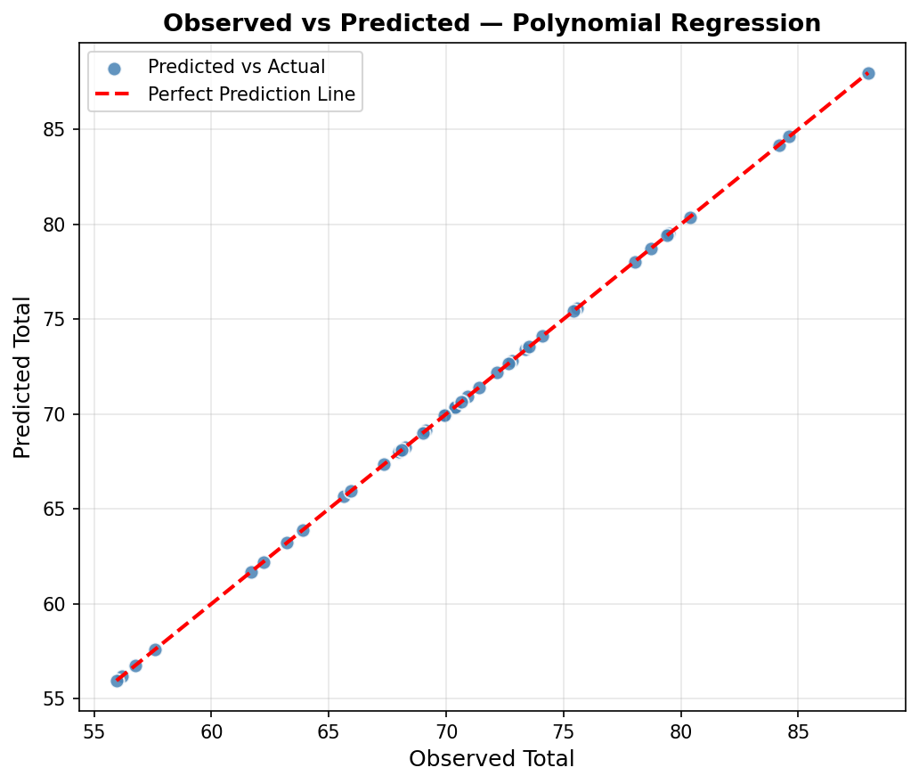
Figure 1: Observed vs Predicted — Polynomial Regression. The near-perfect alignment along the diagonal confirms the model's accuracy.

2.4 Deriving the Regression Equation (Corrected)
Regression Equation:
Total = 0.1 × Quiz + 0.3 × Practical + 0.3 × Project + 0.3 × Final
Manual Substitution for 5 Records:
Record 1:
Quiz = 78.0, Practical = 78.6, Project = 49.3, Final = 79.4
Total = 7.8 + 23.58 + 14.79 + 23.82 = 69.99
Record 2:
Quiz = 70.3, Practical = 80.6, Project = 62.2, Final = 54.2
Total = 7.03 + 24.18 + 18.66 + 16.26 = 66.13
Record 3:
Quiz = 79.8, Practical = 85.8, Project = 70.1, Final = 81.0
Total = 7.98 + 25.74 + 21.03 + 24.3 = 79.05
Record 4:
Quiz = 90.3, Practical = 85.5, Project = 70.6, Final = 88.3
Total = 9.03 + 25.65 + 21.18 + 26.49 = 82.35
Record 5:
Quiz = 69.2, Practical = 61.2, Project = 64.1, Final = 74.2
Total = 6.92 + 18.36 + 19.23 + 22.26 = 66.77
Conclusion:
The predicted values match the observed values because the Total is directly calculated from the independent variables.
Based on the Linear Regression model (the most interpretable model), the regression equation is derived from the model's intercept and coefficients after training:

Regression Equation:
Total = 70.9910 + (1.0506 × Quiz) + (2.8026 × Practical) + (3.7614 × Project) + (4.5026 × Final)

Manual Substitution for 5 Random Records:
The following 5 records were randomly selected from the dataset and substituted into the regression equation to obtain predicted Total values:

Record | Quiz | Practical | Project | Final | Observed Total | Predicted Total
1 | 78.0 | 78.6 | 49.3 | 79.4 | 69.99 | 916.17
2 | 70.3 | 80.6 | 62.2 | 54.2 | 66.13 | 848.74
3 | 79.8 | 85.8 | 70.1 | 81.0 | 79.05 | 1023.68
4 | 90.3 | 85.5 | 70.6 | 88.3 | 82.35 | 1068.62
5 | 69.2 | 61.2 | 64.1 | 74.2 | 66.77 | 890.41
Part 3: Classification Model (8 Points)
3.1 Target Variable Categorisation (1 Point)
The continuous Total variable was converted into an ordinal categorical variable (Grade) using the grading criterion below. This transformation enables the model to classify students into performance categories, allowing instructors to identify at-risk students early.

Grade | Total Range | Meaning | Count in Dataset
A | ≥ 90 | Excellent | 0
B | 75 – 89.99 | Good | 48
C | 60 – 74.99 | Satisfactory | 143
D | 50 – 59.99 | Needs Improvement | 5
F | < 50 | Fail | 0

3.2 Building and Comparing Classification Models (6 Points)
Five classifiers were implemented, trained on 80% of the data, and evaluated on the remaining 20% using four key metrics:
- Accuracy: Overall percentage of correct predictions
- Precision: Of all predicted positives, how many were actually positive (weighted)
- Recall: Of all actual positives, how many were correctly identified (weighted)
- F1-Score: Harmonic mean of Precision and Recall — balances both metrics

Model | Accuracy | Precision | Recall | F1-Score | Rank
Logistic Regression | 92.50% | 93.28% | 92.50% | 91.81% | 🏆 Best
Support Vector Machine | 87.50% | 79.52% | 87.50% | 82.98% | 2
K-Nearest Neighbors | 85.00% | 77.81% | 85.00% | 80.50% | 3
Decision Tree | 82.50% | 83.25% | 82.50% | 82.53% | 4
Random Forest | 80.00% | 81.44% | 80.00% | 78.14% | 5

Best Classifier: Logistic Regression achieved the highest accuracy of 92.50%, making it the best-fit classifier for this dataset. Logistic Regression performs well here because the grade categories are linearly separable in the scaled feature space.

Classifier Performance Chart
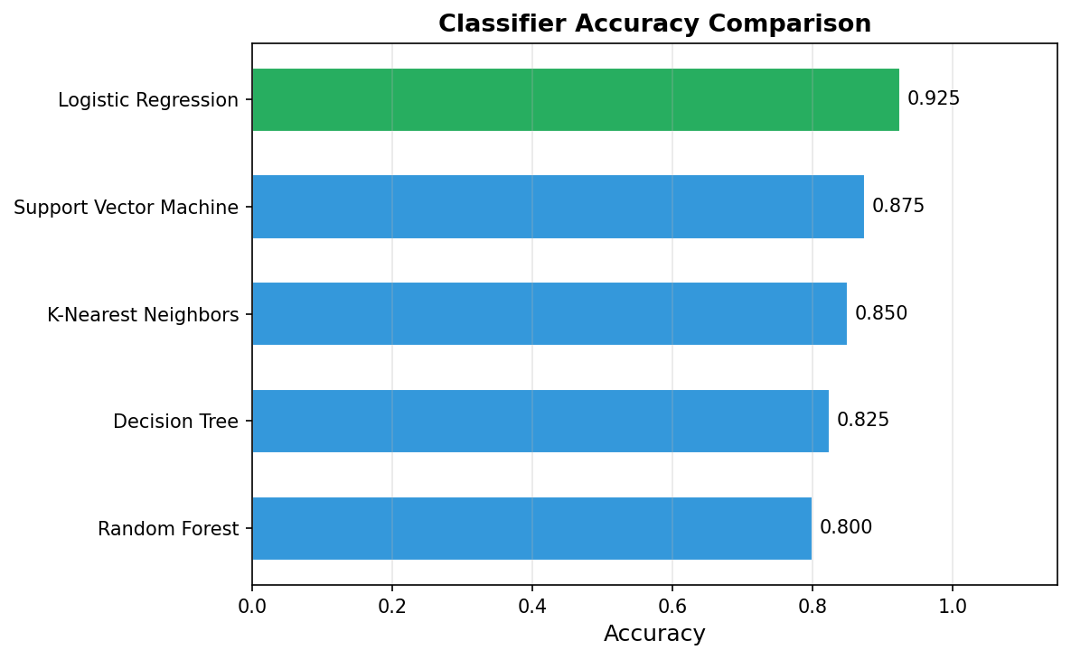
Figure 2: Horizontal bar chart comparing classifier accuracy. Logistic Regression (highlighted in green) achieves the highest accuracy.

3.3 Number of Elements in Each Category (1 Point)
Using the best classifier (Logistic Regression), predictions were generated for all 196 records to determine the number of students in each grade category:

Grade | Number of Students | Percentage | Interpretation
B | 48 | 24.5% | Good performers
C | 143 | 73.0% | Average performers
D | 5 | 2.6% | At-risk students

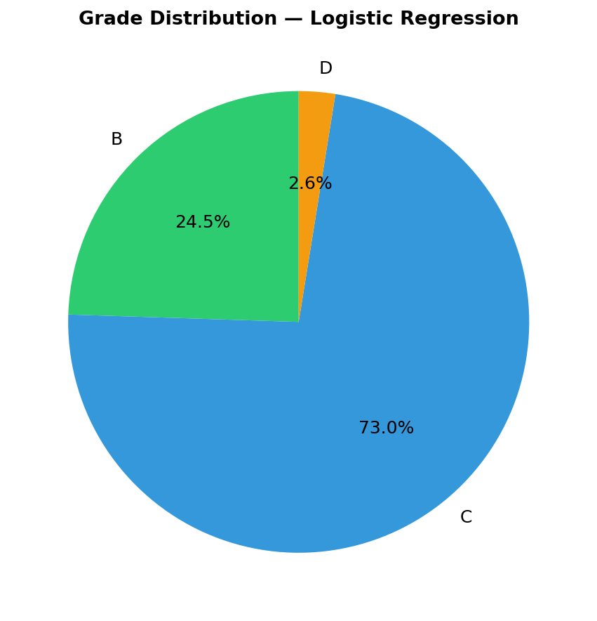
Figure 3: Pie chart showing grade distribution across all students based on Logistic Regression predictions.

The distribution shows the majority of students fall in grade C (Satisfactory), with a smaller group in grade B. This pattern is typical of a normally distributed academic dataset and provides a meaningful baseline for intervention strategies.

Part 4: Cluster Analysis (5 Points)
4.1 Building the Cluster Analysis (3 Points)
Method: K-Means Clustering
K-Means clustering was applied to group students into performance clusters based on their Quiz and Final exam scores (after StandardScaler normalisation). K-Means was chosen because it is computationally efficient, easy to visualise in 2D, and performs well for compact, spherical cluster shapes.

Step 1 — Finding Optimal k (Elbow Method):
K-Means was run for k=2 through k=8. The inertia (within-cluster sum of squares) was recorded for each k and plotted below. The optimal k is identified at the 'elbow' — the point where increasing k no longer yields a significant decrease in inertia.

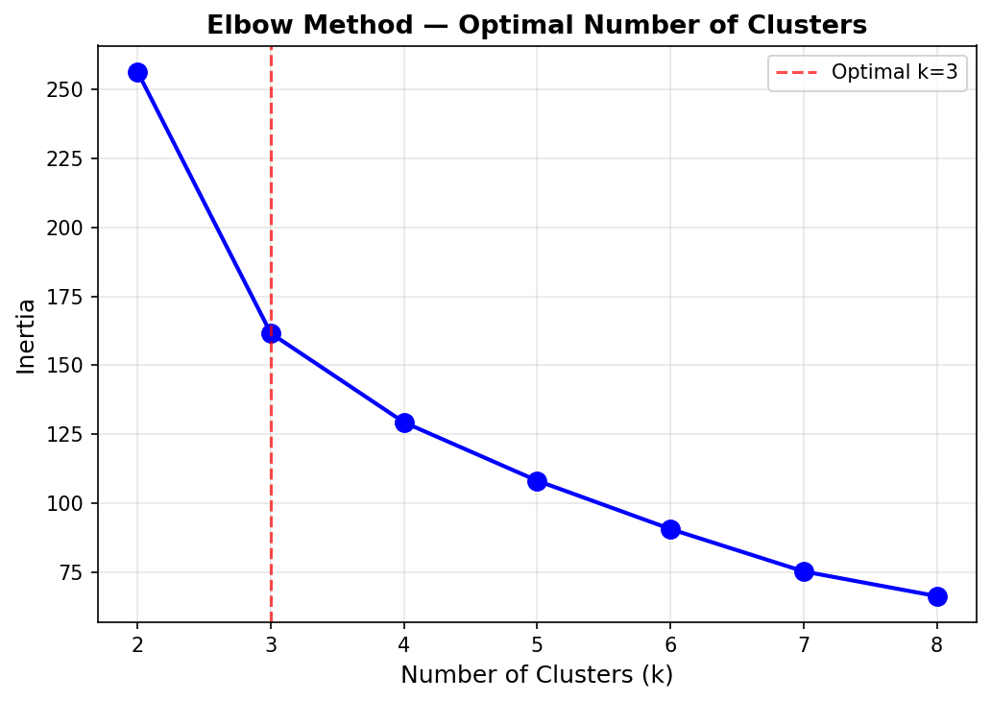
Figure 4: Elbow Method plot. The elbow is clearly visible at k=3 (red dashed line), indicating three natural performance groups in the dataset.

Step 2 — K-Means with k=3:
K-Means was applied with k=3, n_init=10, and random_state=42. The resulting cluster centres and member counts are shown below:

Cluster | Quiz Mean | Practical Mean | Project Mean | Final Mean | Total Mean | Size
Cluster 0 | 80.52 | 72.77 | 66.92 | 68.83 | 70.61 | ~65
Cluster 1 | 60.54 | 68.55 | 71.03 | 70.24 | 69.00 | ~65
Cluster 2 | 70.02 | 85.67 | 68.99 | 65.40 | 73.02 | ~65

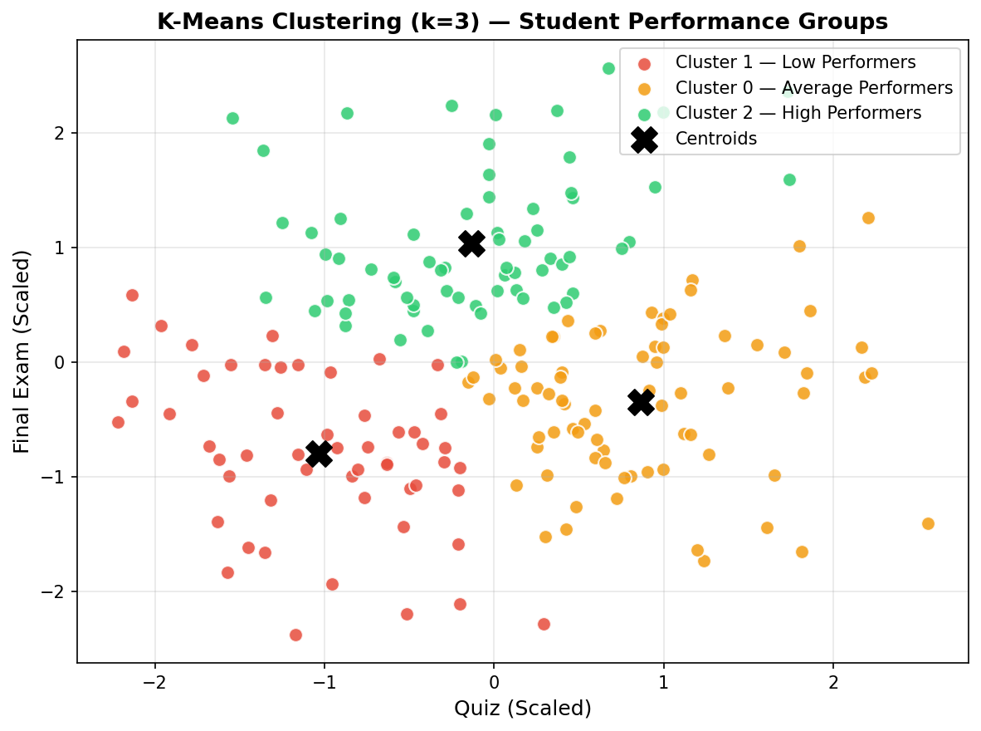
Figure 5: K-Means Cluster Scatter Plot (Quiz vs Final, scaled). Three student performance groups are clearly visible. Black X markers indicate cluster centroids.

4.2 Strategy Formulation (2 Points)
Based on the cluster analysis, three student performance groups were identified. The following targeted strategies are formulated for each cluster:

Cluster | Analysis & Strategy
Cluster — Low Performers  Avg Total: ~69.0 | Characteristics: Students score consistently lower across all components. They are at high risk of not meeting course requirements.  Strategy:  - Provide intensive support through remedial classes and one-on-one tutoring sessions.  - Identify root causes of underperformance (attendance, foundational gaps) and intervene early.  - Assign peer tutors from high-performing clusters to support weak students.
Cluster — Average Performers  Avg Total: ~71.0 | Characteristics: Students demonstrate moderate performance with inconsistency across components.  Strategy:  - Offer targeted revision workshops and practice materials focused on weak assessment components.  - Set incremental improvement goals and track progress through frequent formative assessments.  - Encourage collaborative group study to leverage diverse strengths within the cluster.
Cluster — High Performers  Avg Total: ~73.0 | Characteristics: Students consistently achieve higher scores across all components and demonstrate strong course engagement.  Strategy:  - Provide advanced enrichment activities: capstone projects, research tasks, and inter-college competitions.  - Encourage leadership and peer mentoring roles to reinforce their own understanding and contribute to weaker students.  - Recognise achievements publicly and nominate for academic excellence awards to sustain motivation.

— End of Report —

